8. Check iwconfig/ifconfig to understand in detail about network interfaces (check about interface speed, MTU and other parameters)

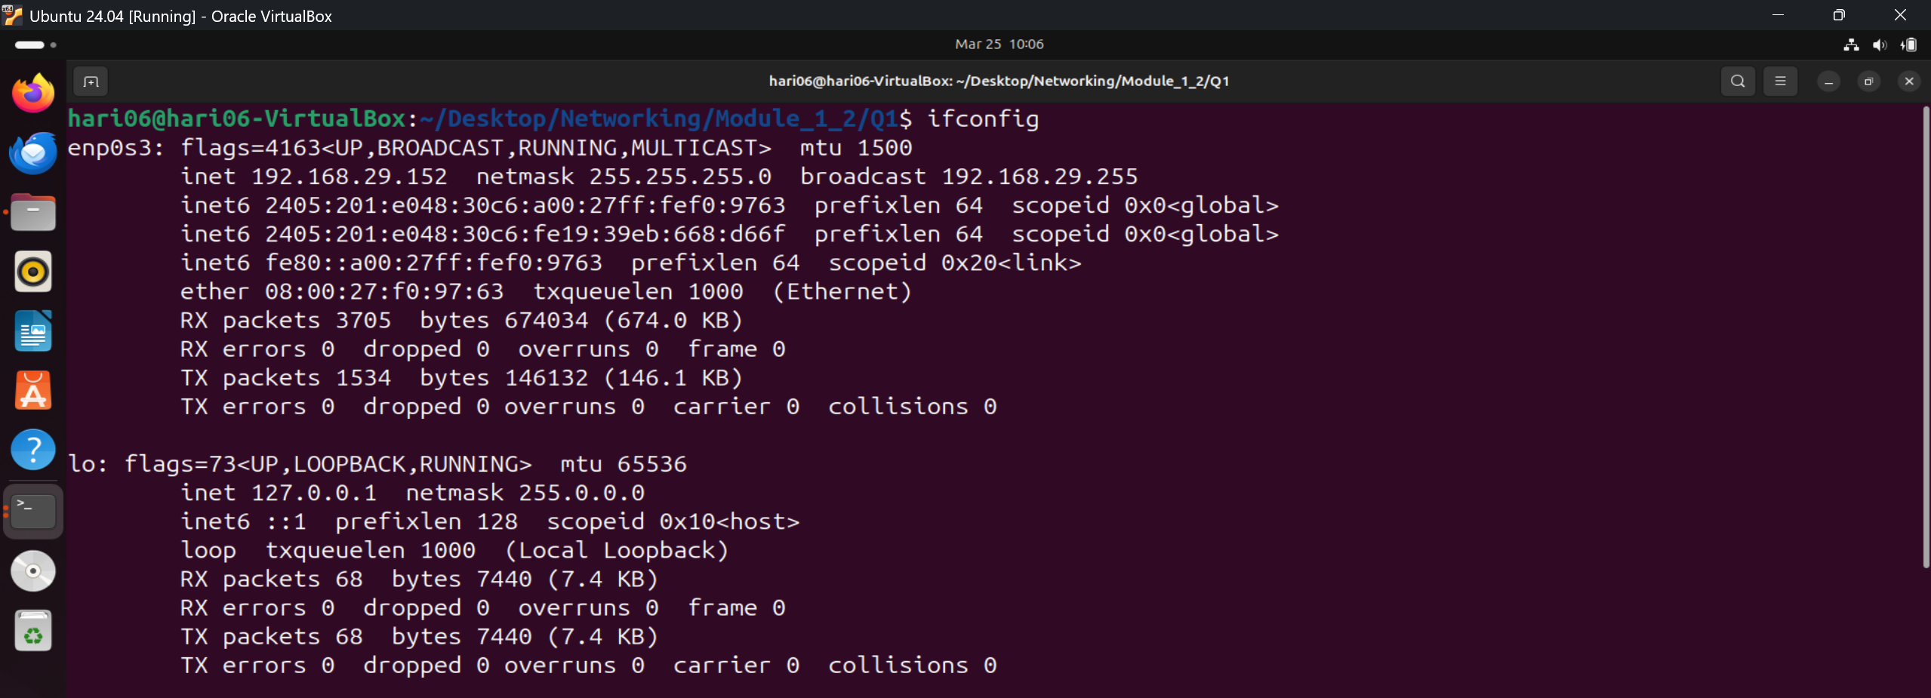
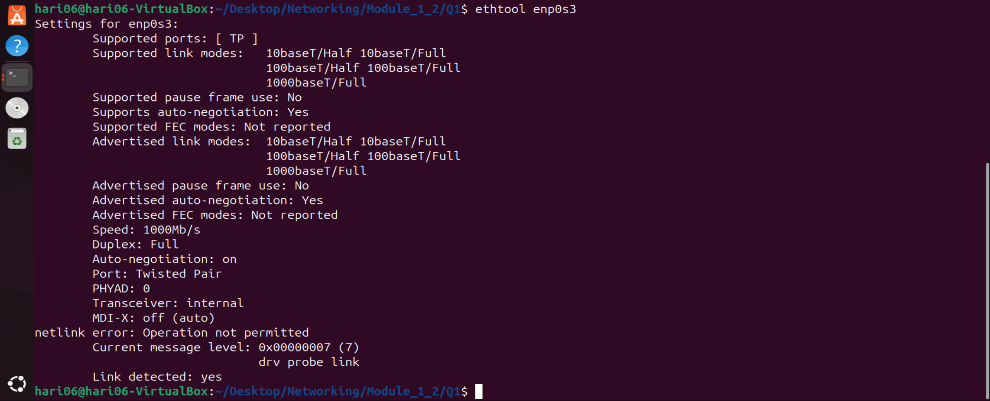

Interface |  | Meaning
lo |  | Loopback interface
enp0s3 |  | Ethernet interface
Flag |  | Meaning
UP |  | Interface is enabled
BROADCAST |  | Can send broadcast packets
RUNNING |  | Device is working
MULTICAST |  | Supports multicast
IP Address | 192.168.29.152

Netmask | 255.255.255.0

Broadcast | 192.168.29.255

